Module 7: Redshift Assignment

Problem Statement: You work for XYZ Corporation. Their application requires a database service that can store data which can be retrieved if required. Implement suitable service for the same.
While migrating, you are asked to perform the following tasks:
1. Create a Redshift data warehouse.
2. Using the query editor:
a. Load some data
b. Query the data
Creating Serverless Redshift:
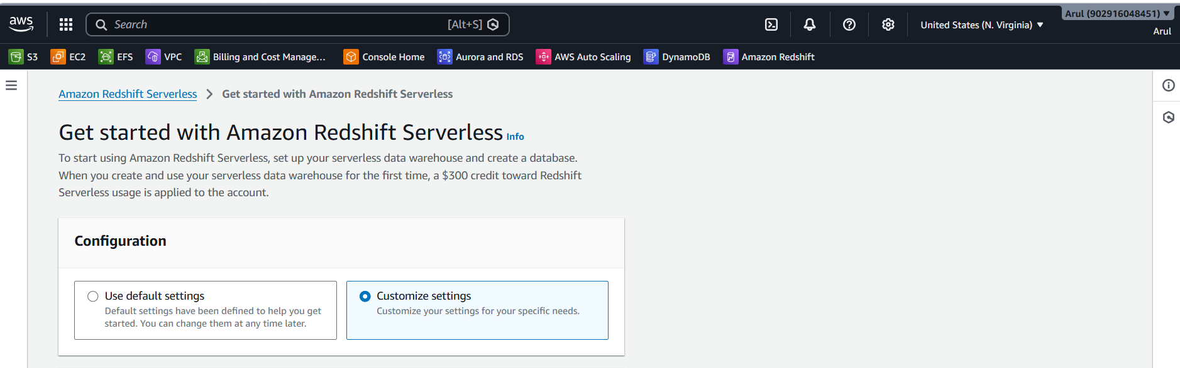
Namespace: my-redshift-demo and setting credentials
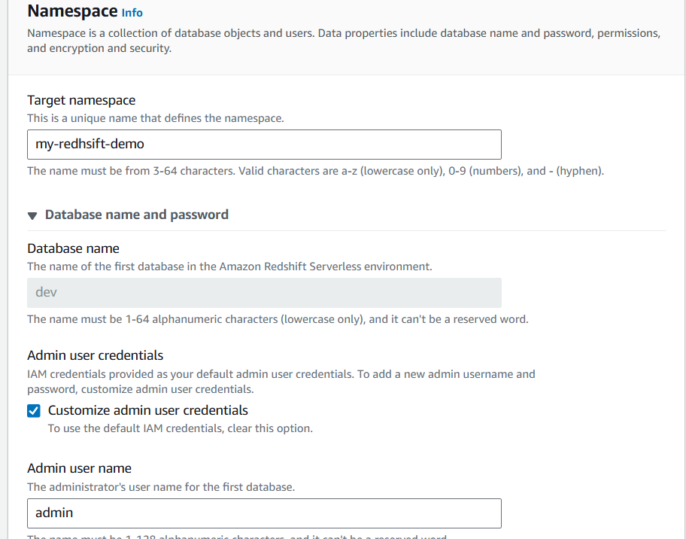

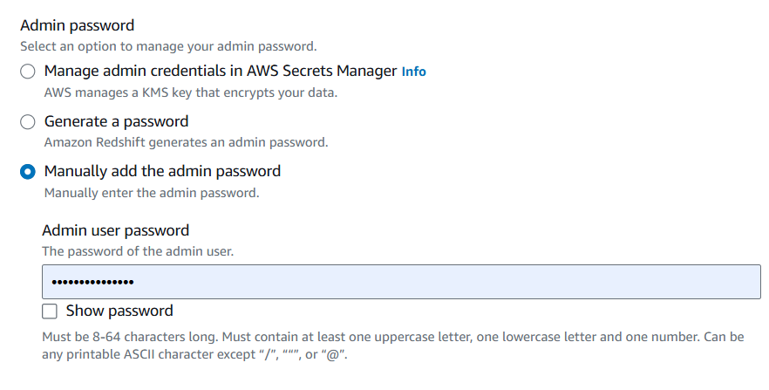
Creating the IAM role:
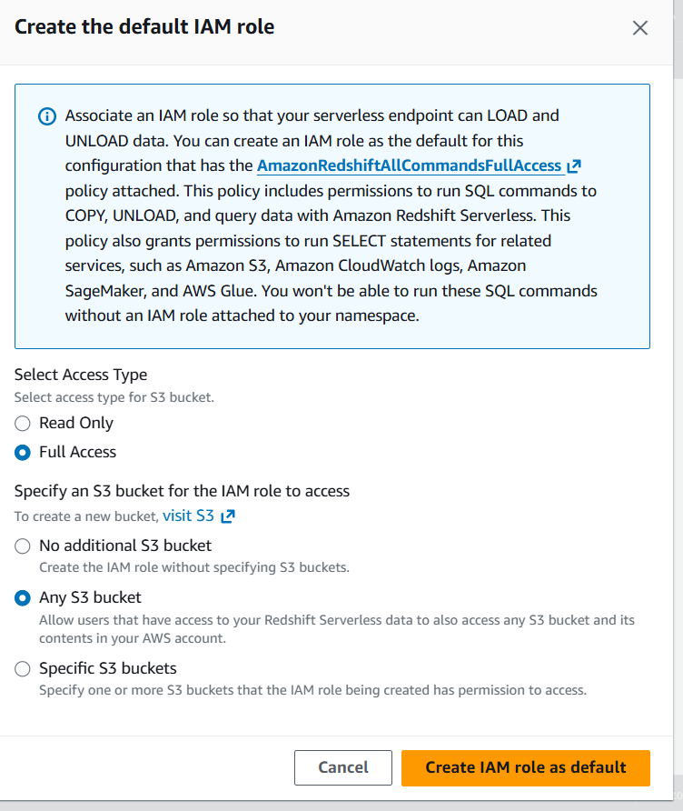
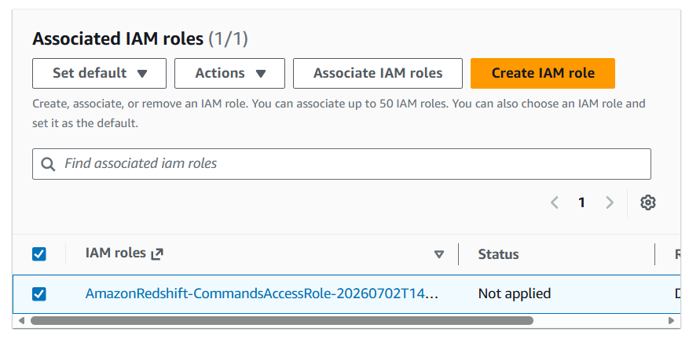
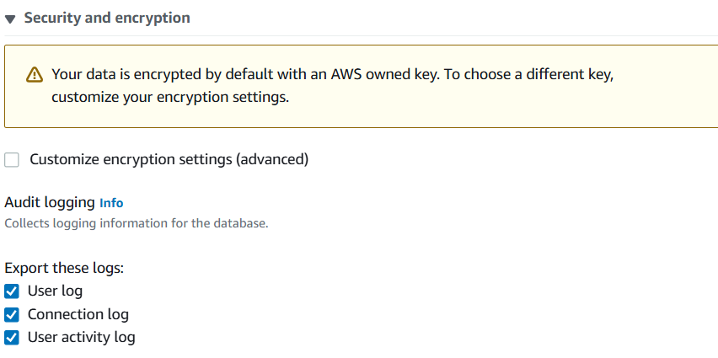
Creating the workgroup: my-demo-workgroup
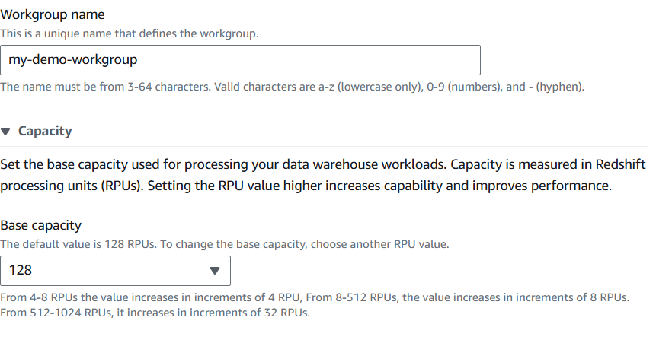
Network setting:
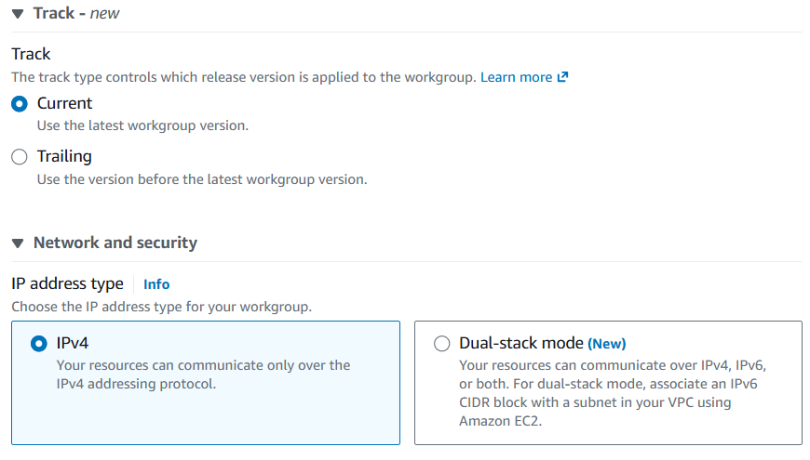

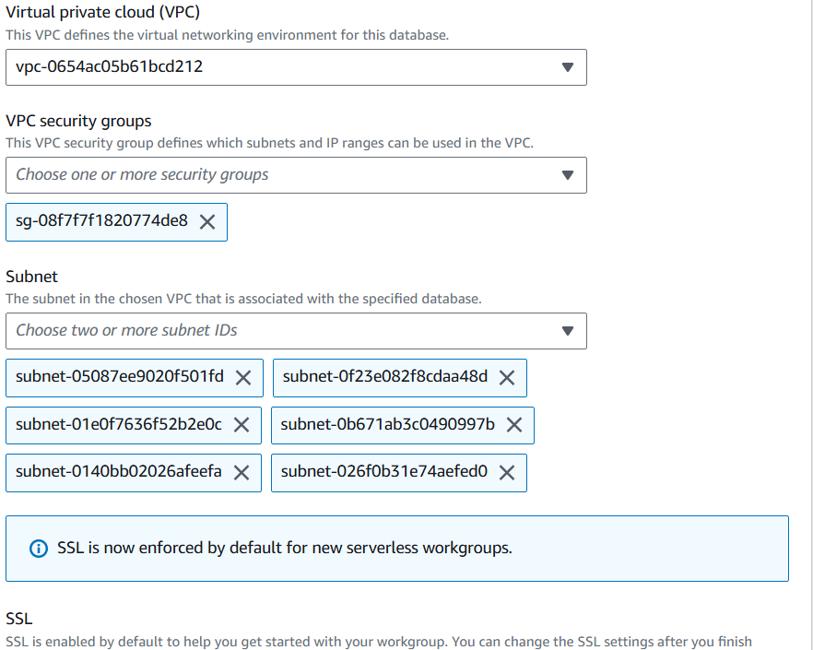

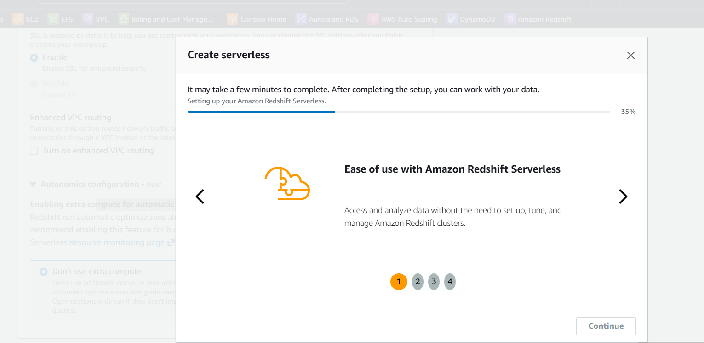
Both namespace and workgroup created:
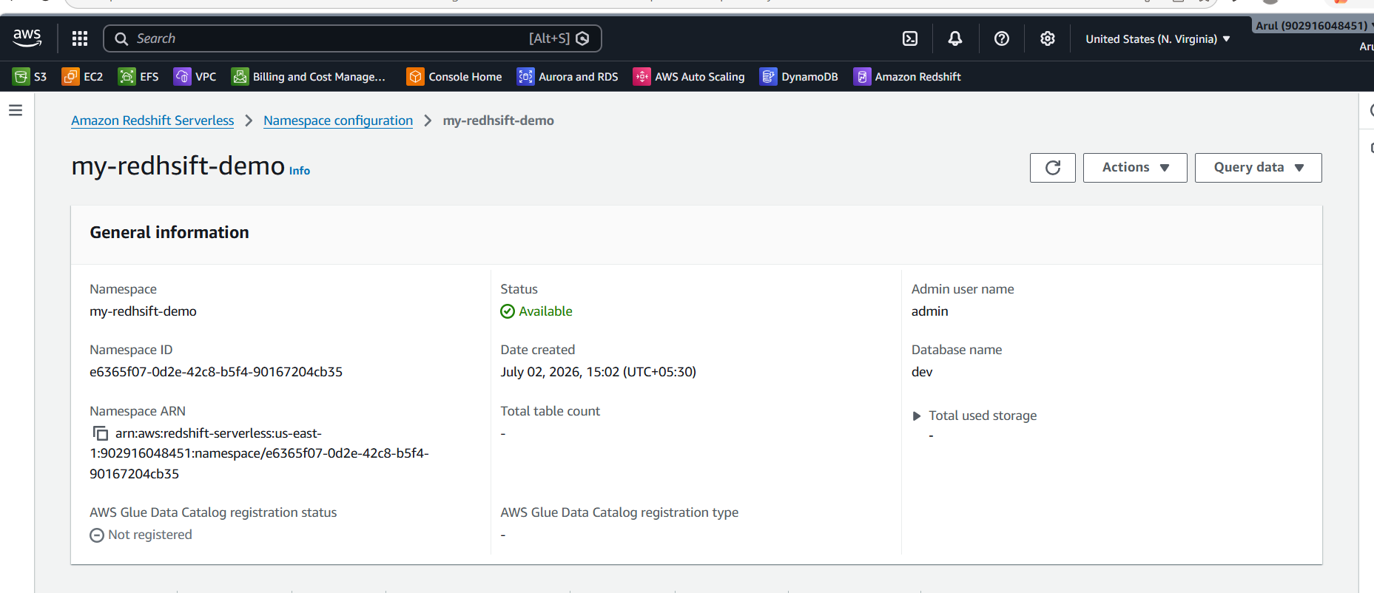

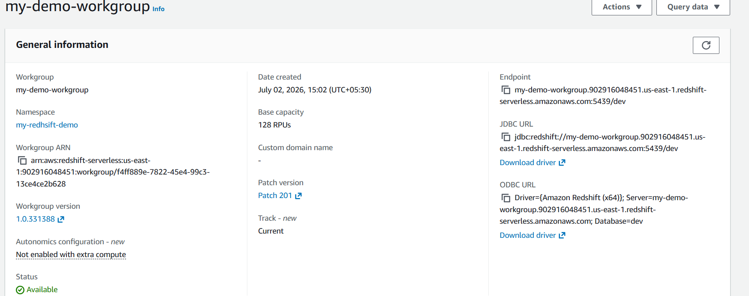

Creating the S3 bucket to load the data (CSV file):
Bucket name: redshift-employee-demo
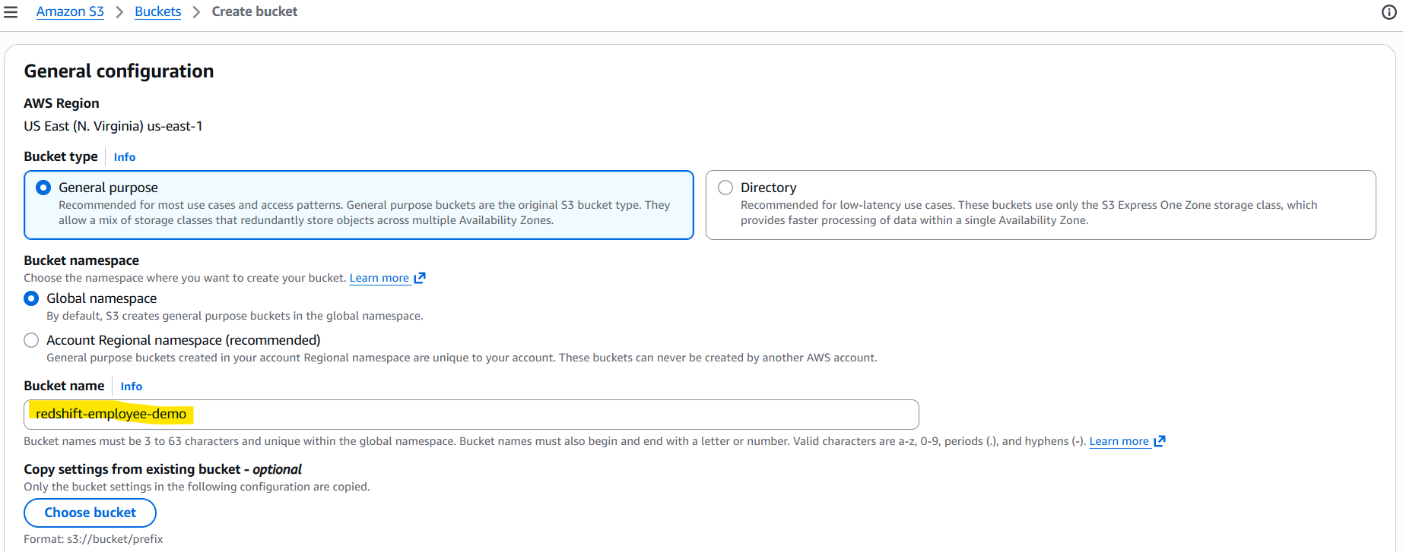
Enabling ACL:
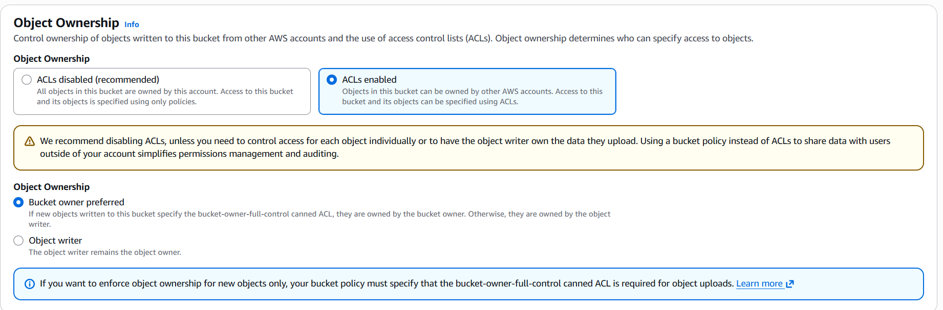
Enabling Public Access:
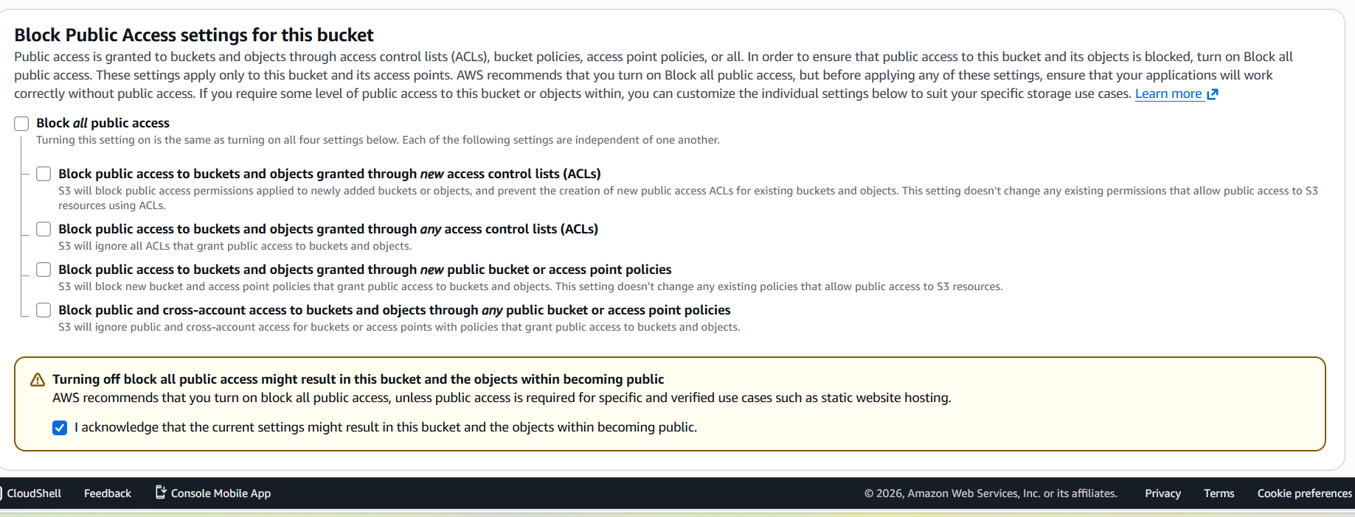
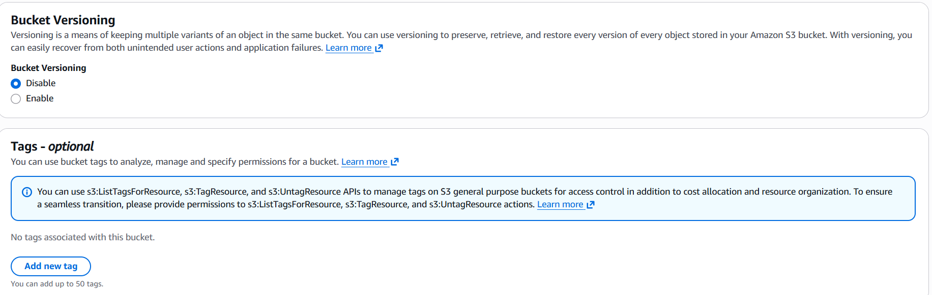
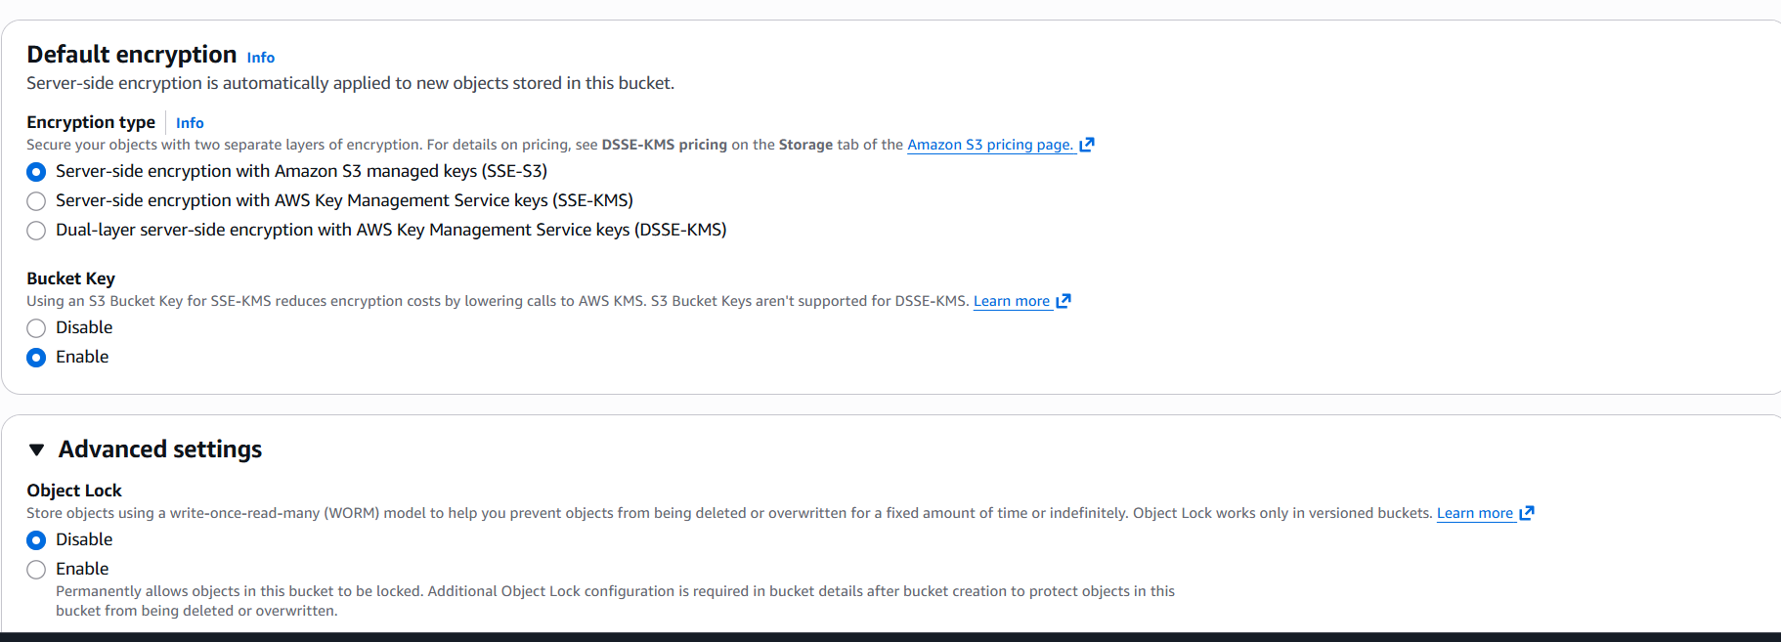
Bucket is created:
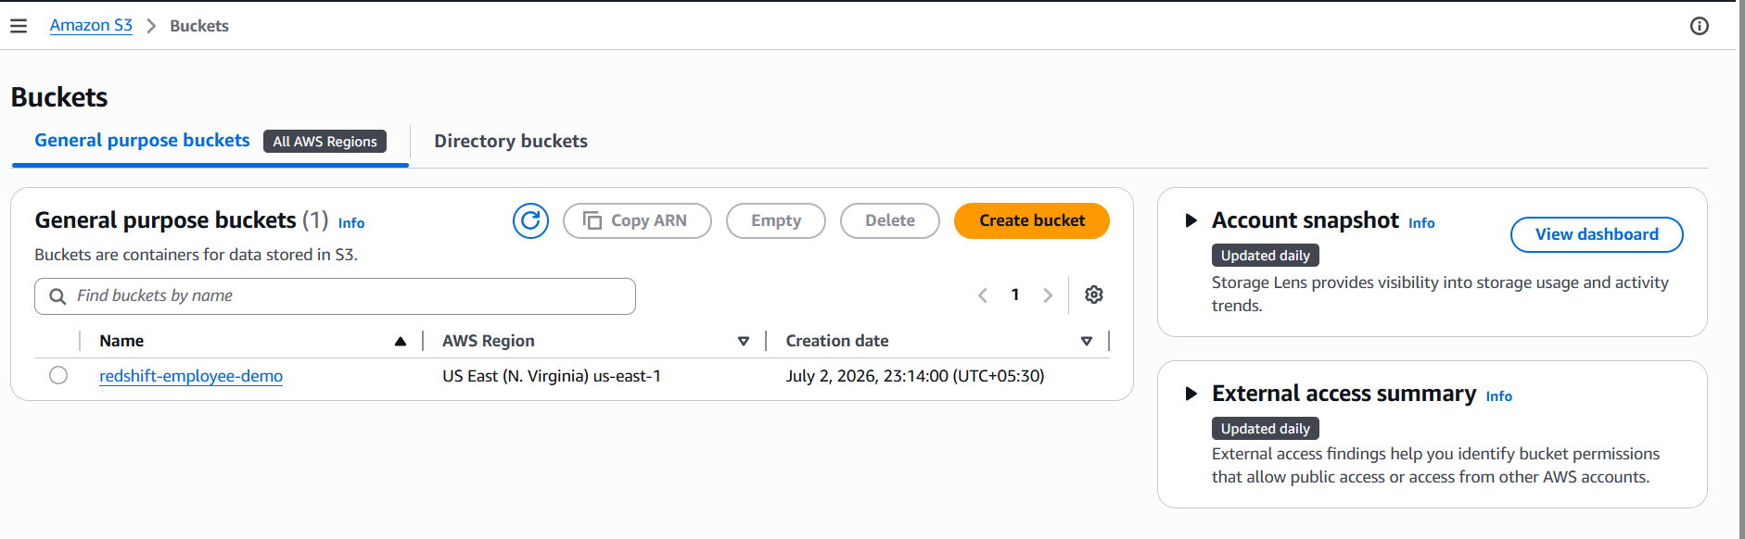
Uploading the employee.csv file to S3:
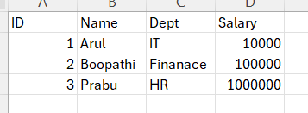

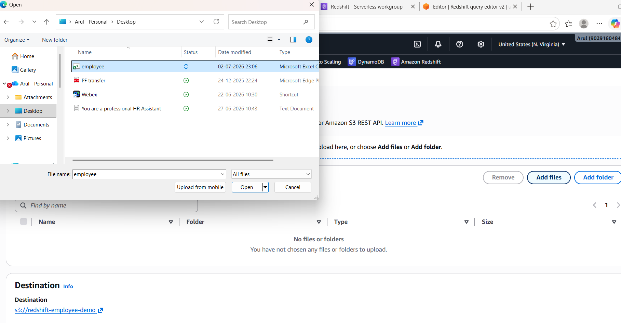
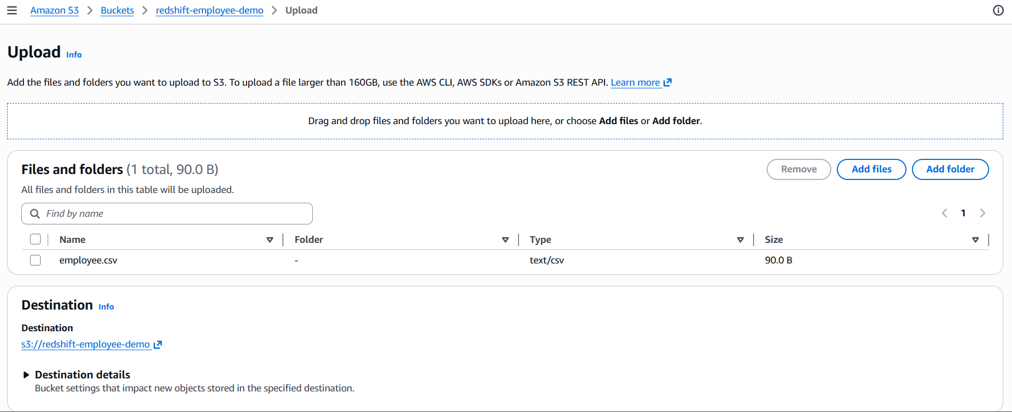
Make Public using ACL for the object:
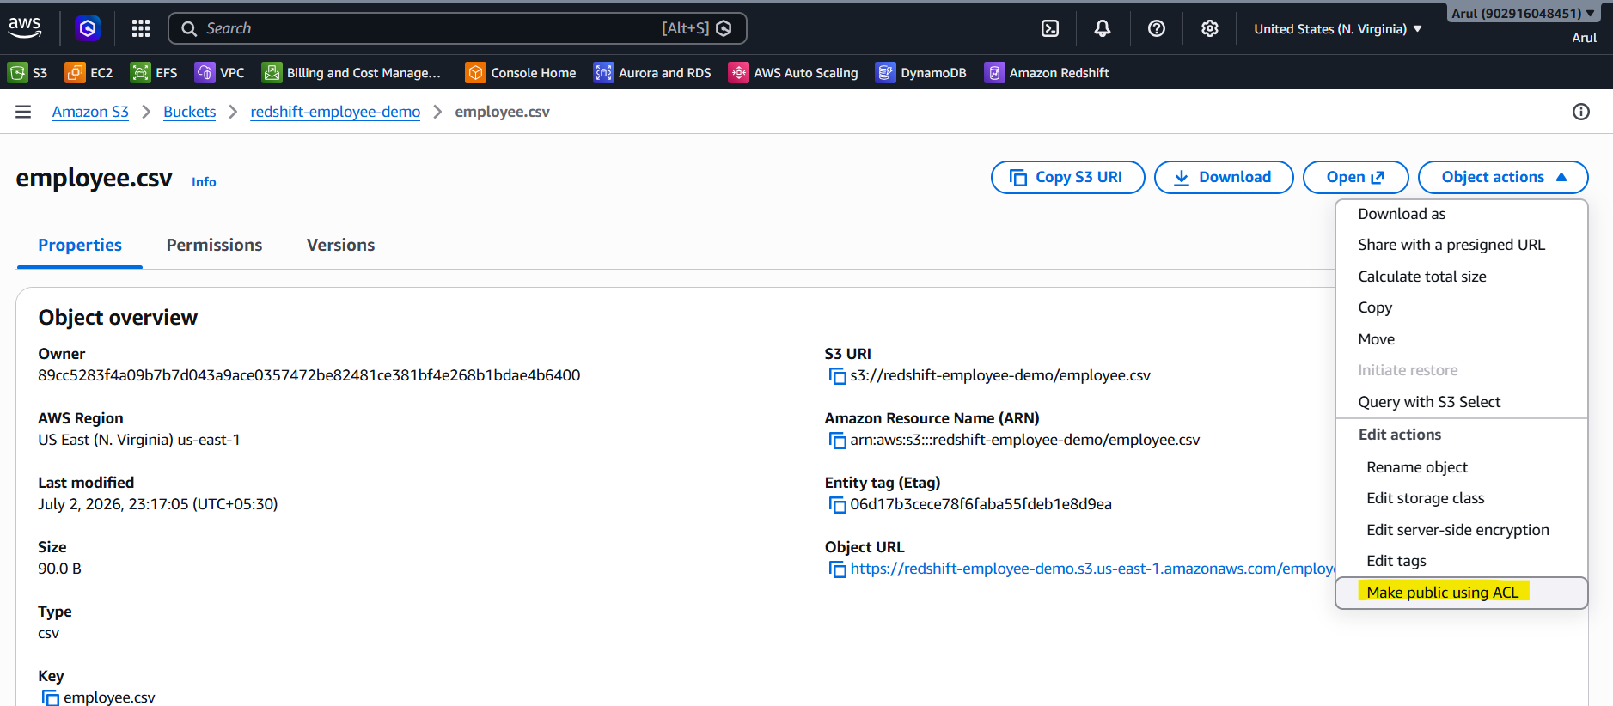
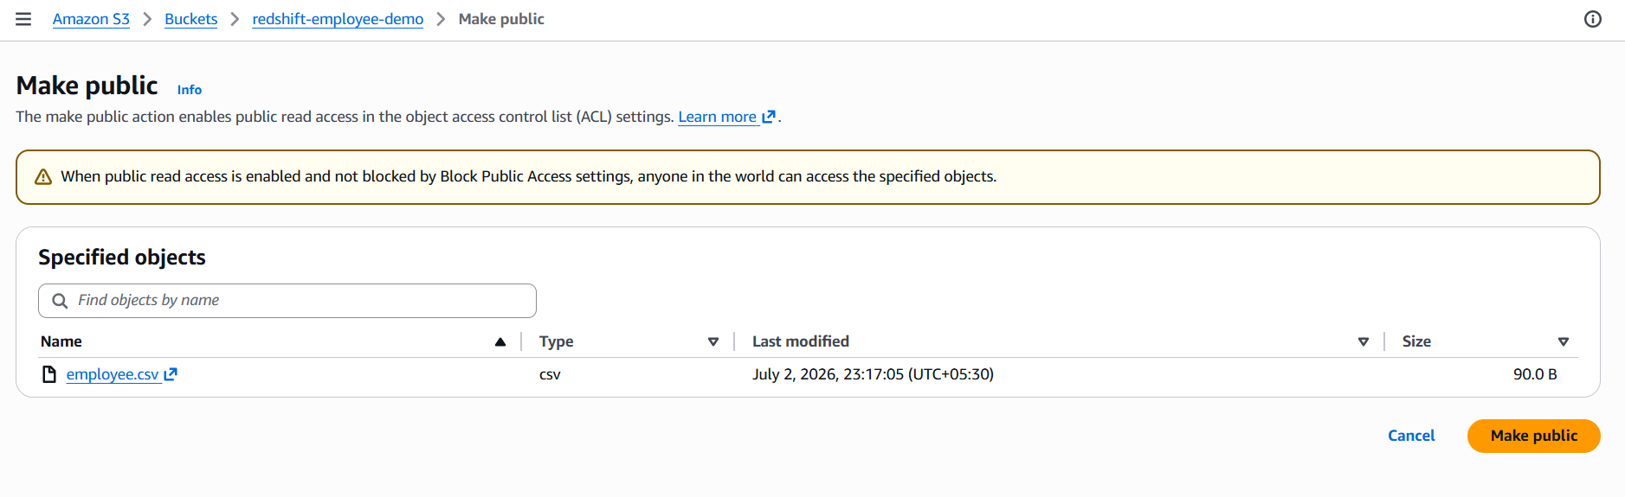
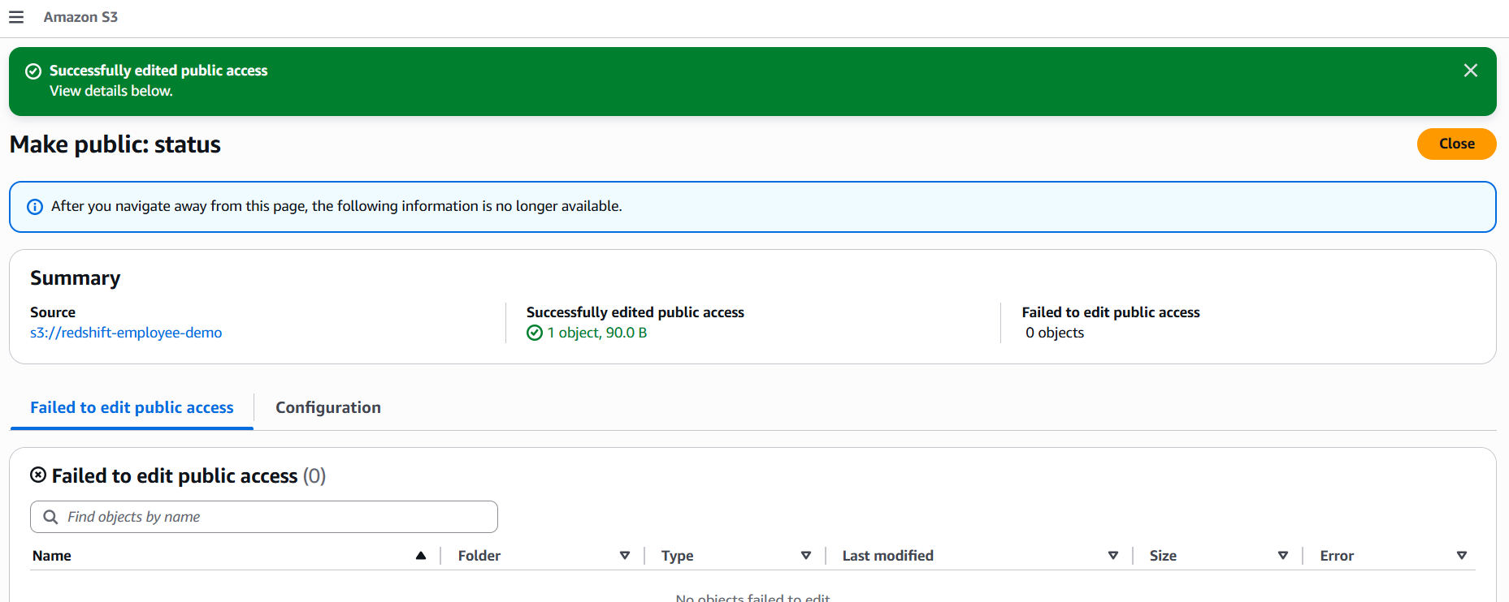

Loading the data in the Redshift Query editor:
Open and select the Load data:
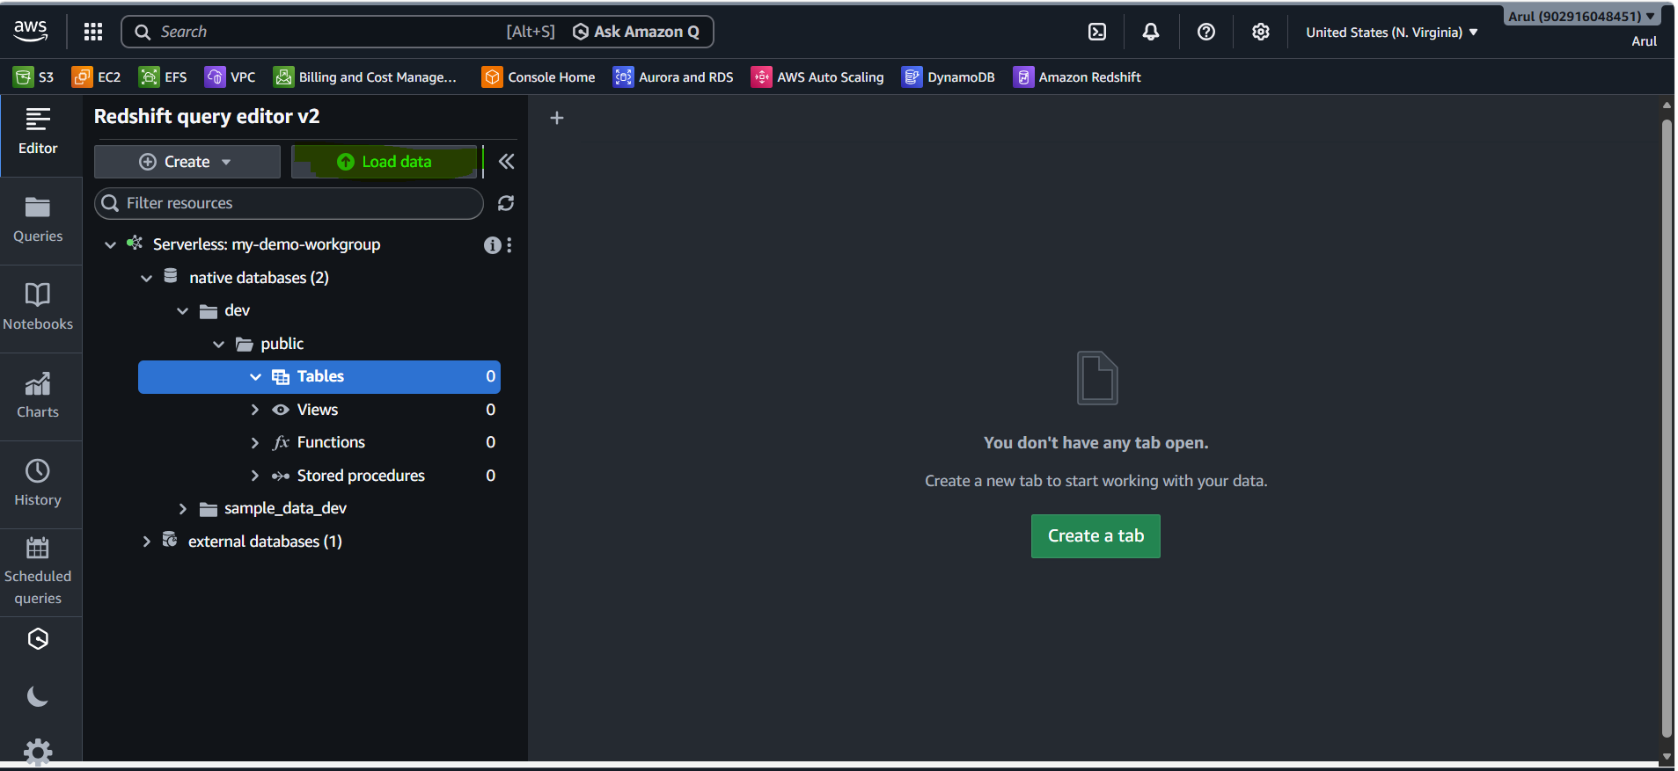
Select the data source: object URI
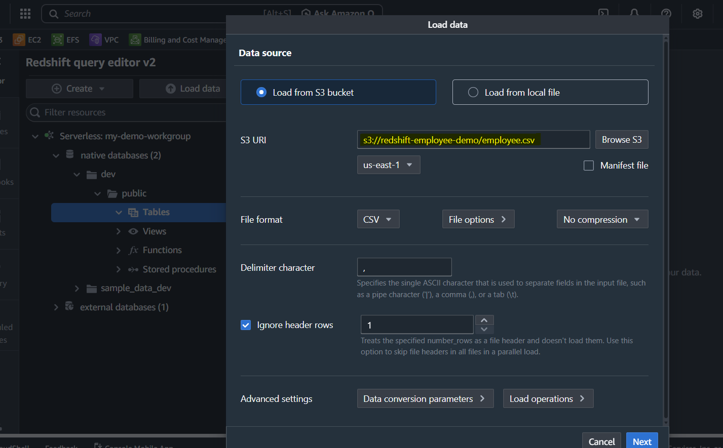
Create the table employees with custom attributes as below:
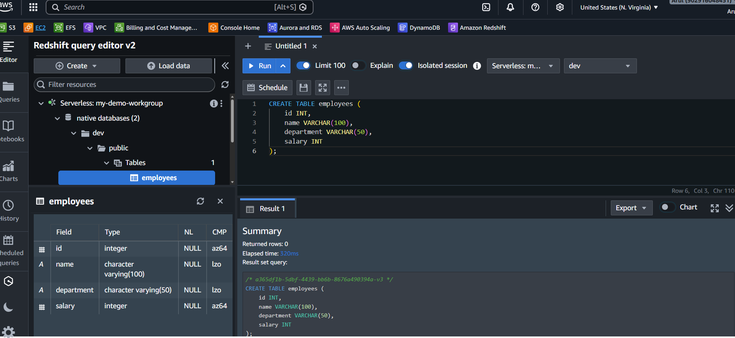

Create the IAM role to access the S3 data:
Select AWS service:
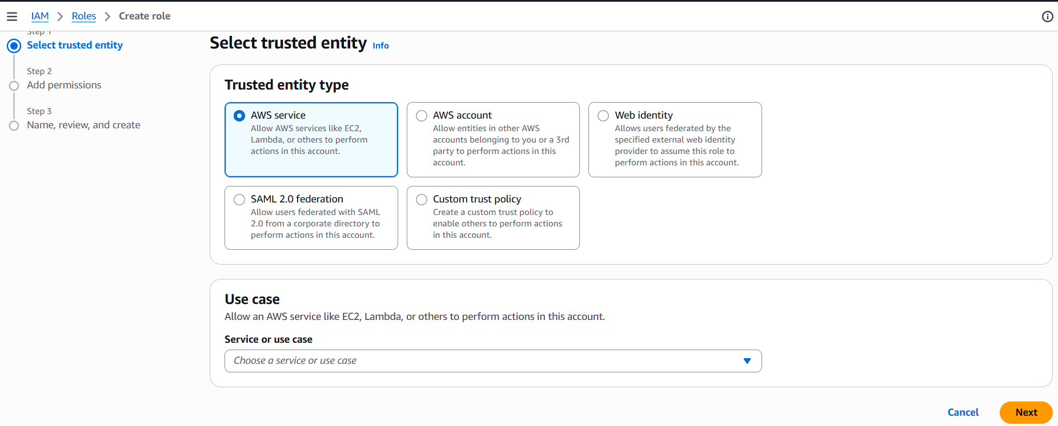
Use case name: Redhsift
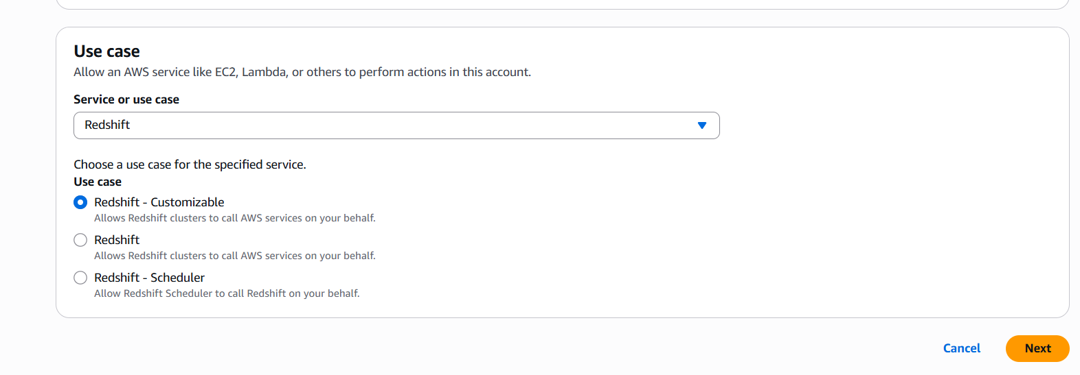
Select S3 readonly access
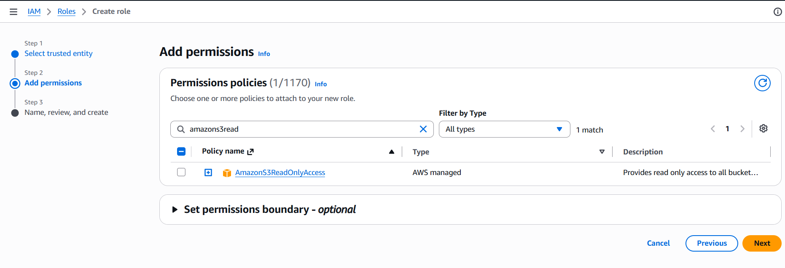
Specify the role name: RedshiftS3Role
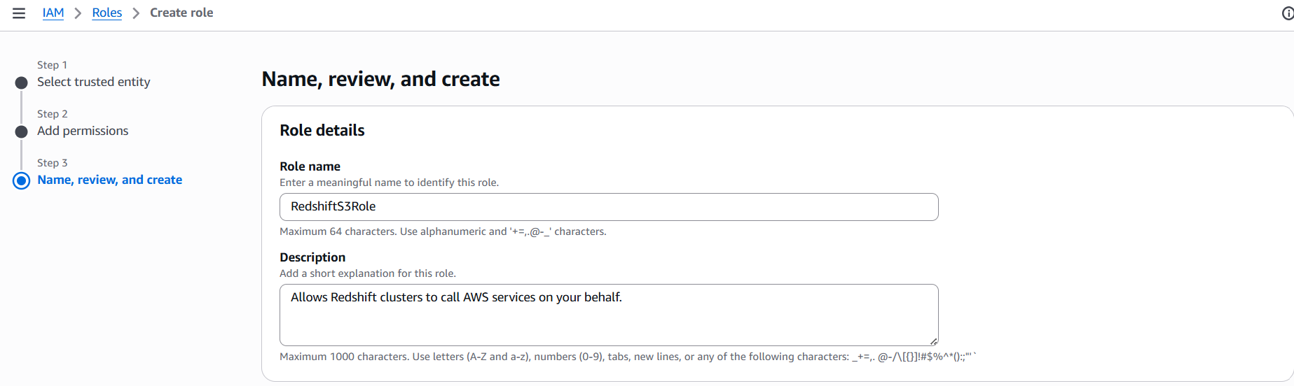
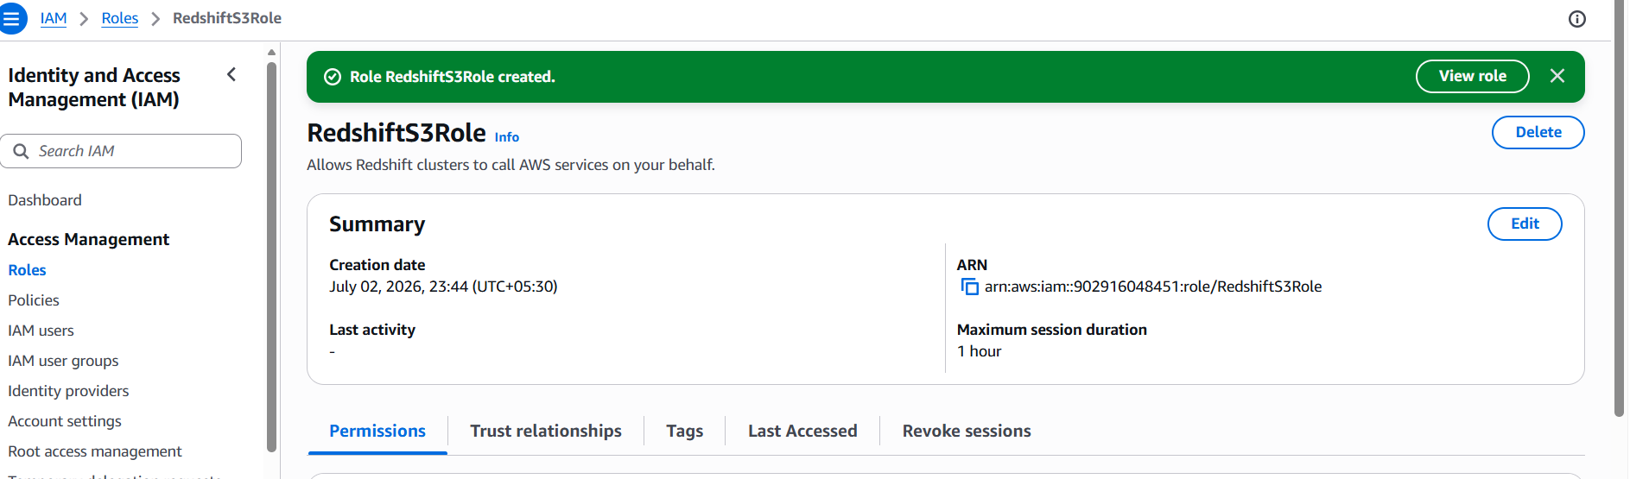
Select the Redshift namespace to add the IAM role:
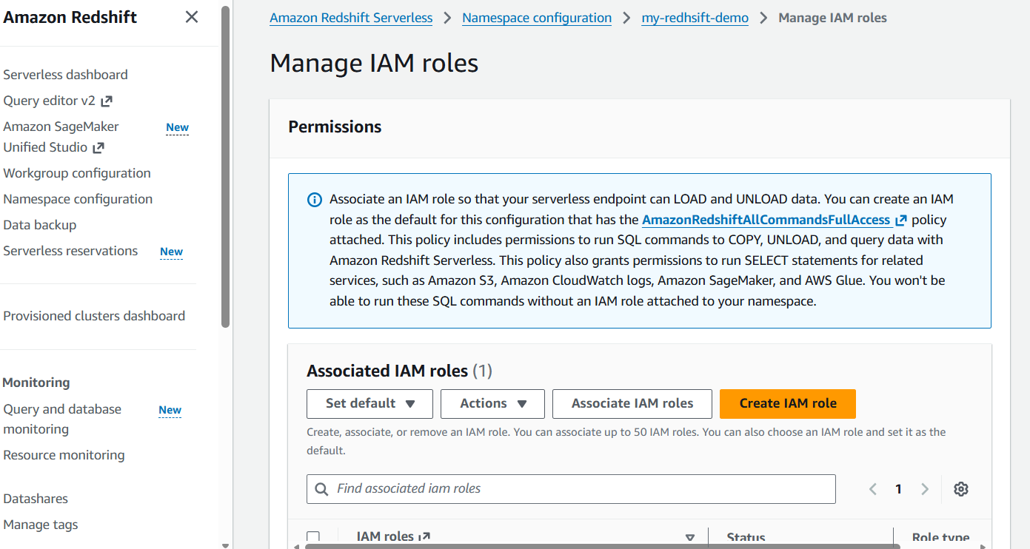

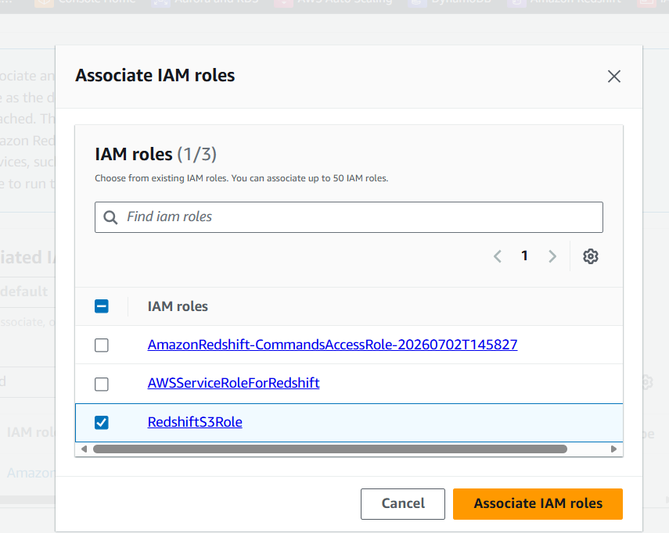
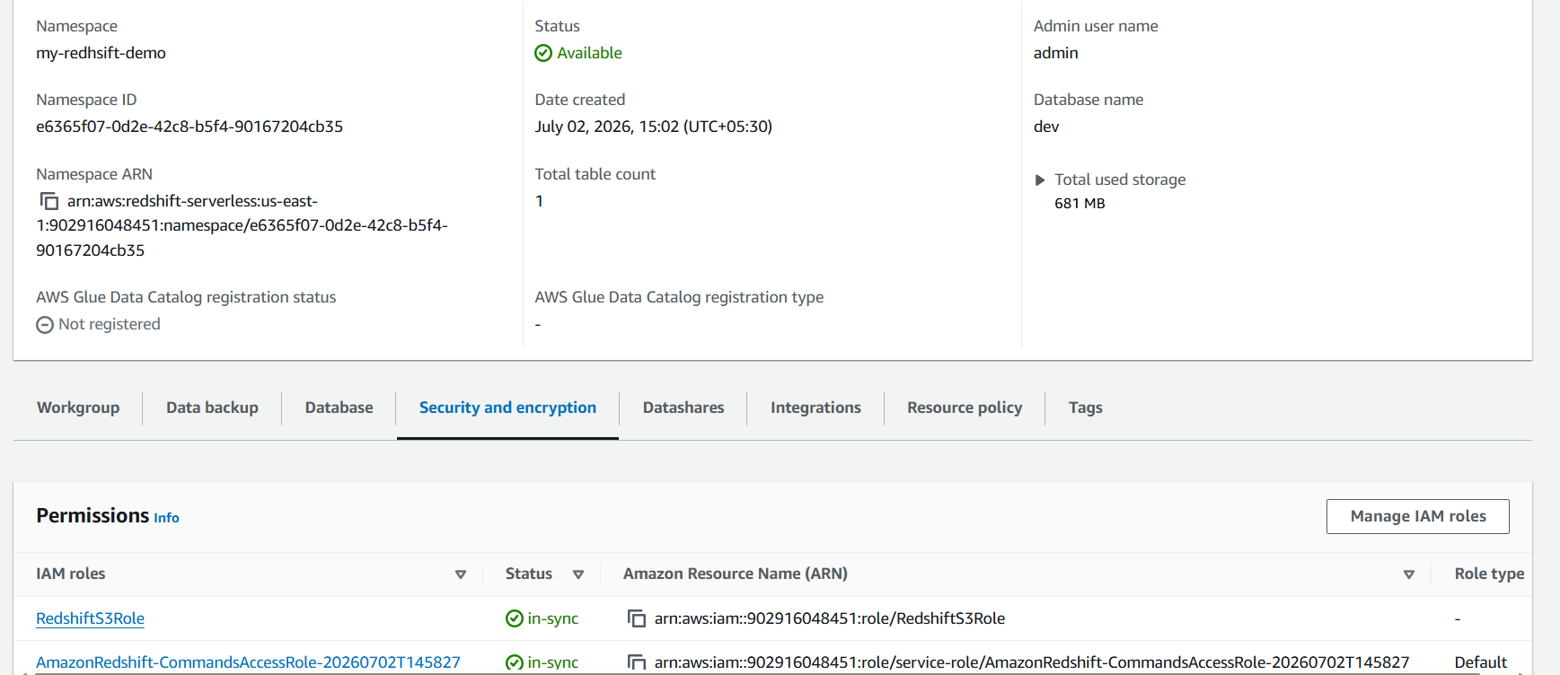
Copy the data from the S3 bucket to employees table as below:
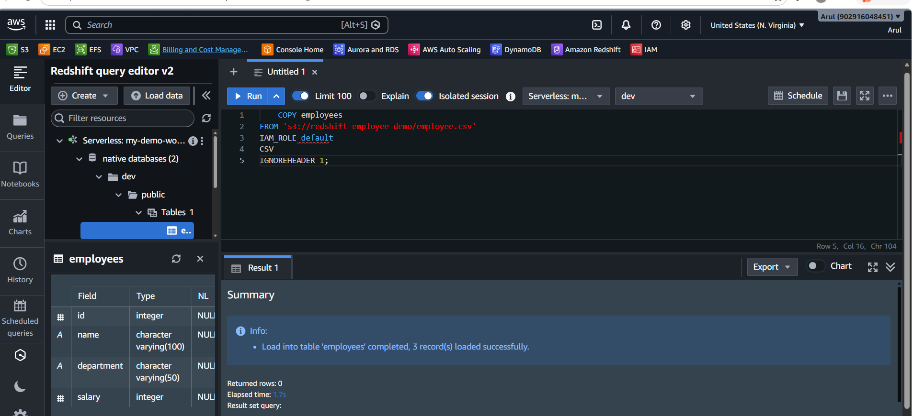
Query the data & validate the output using select query:
